

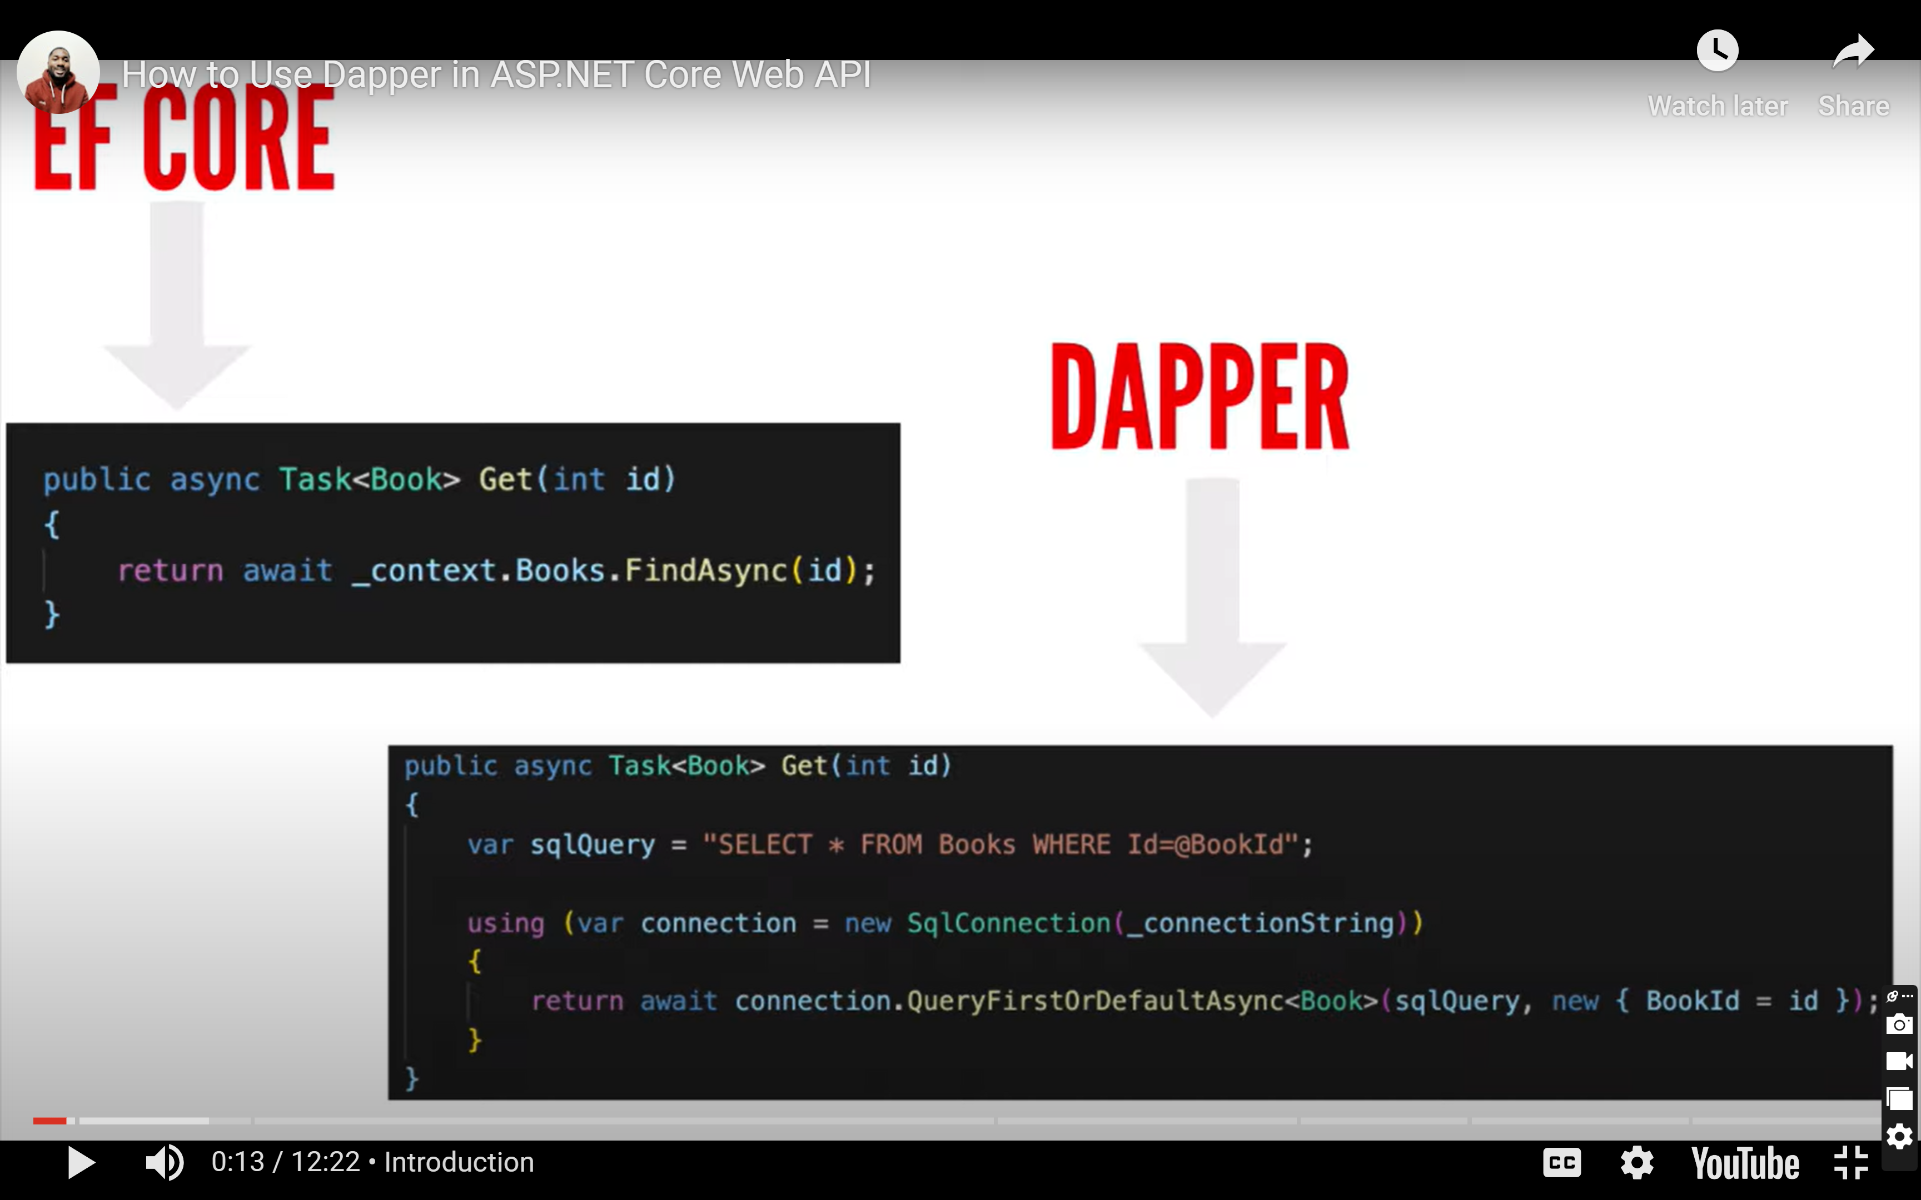

Using ADO.Net

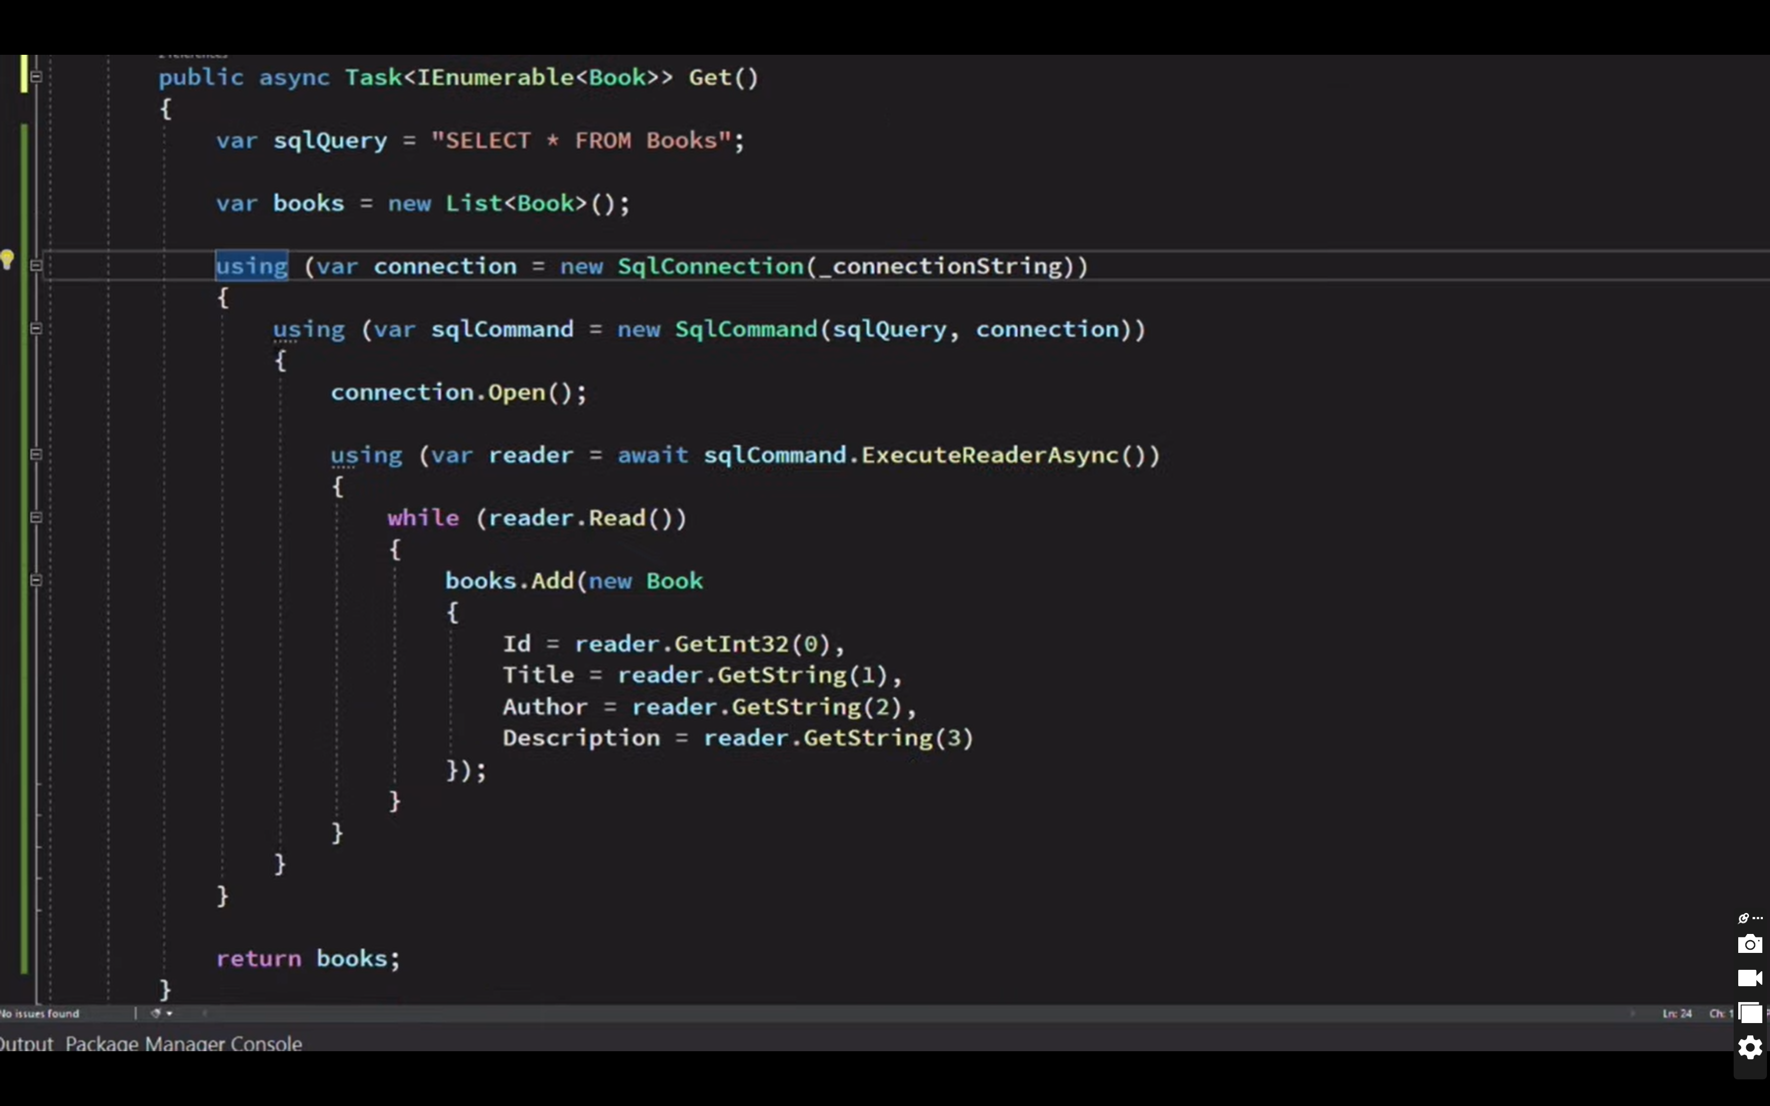

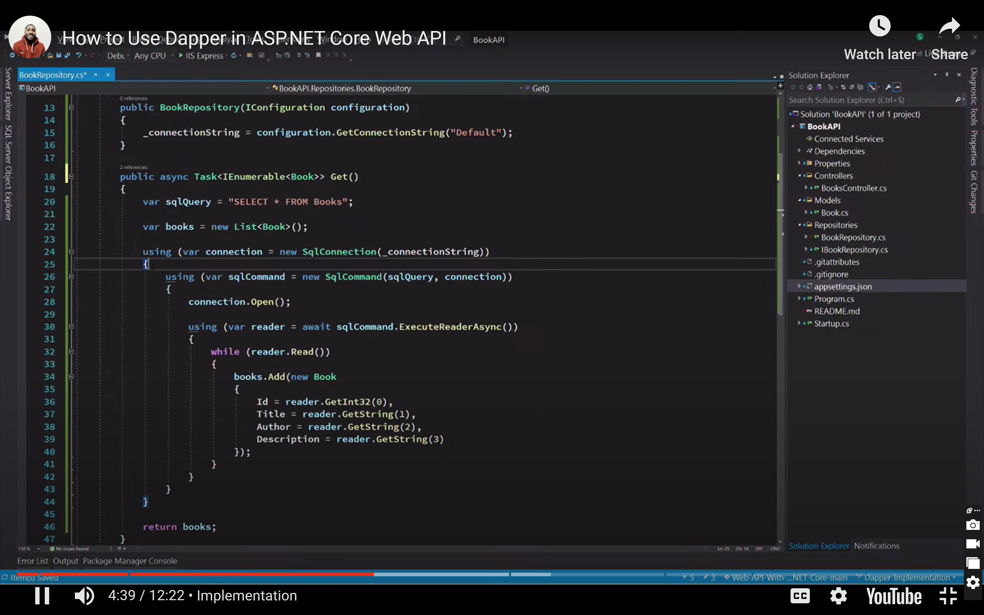

Install daper

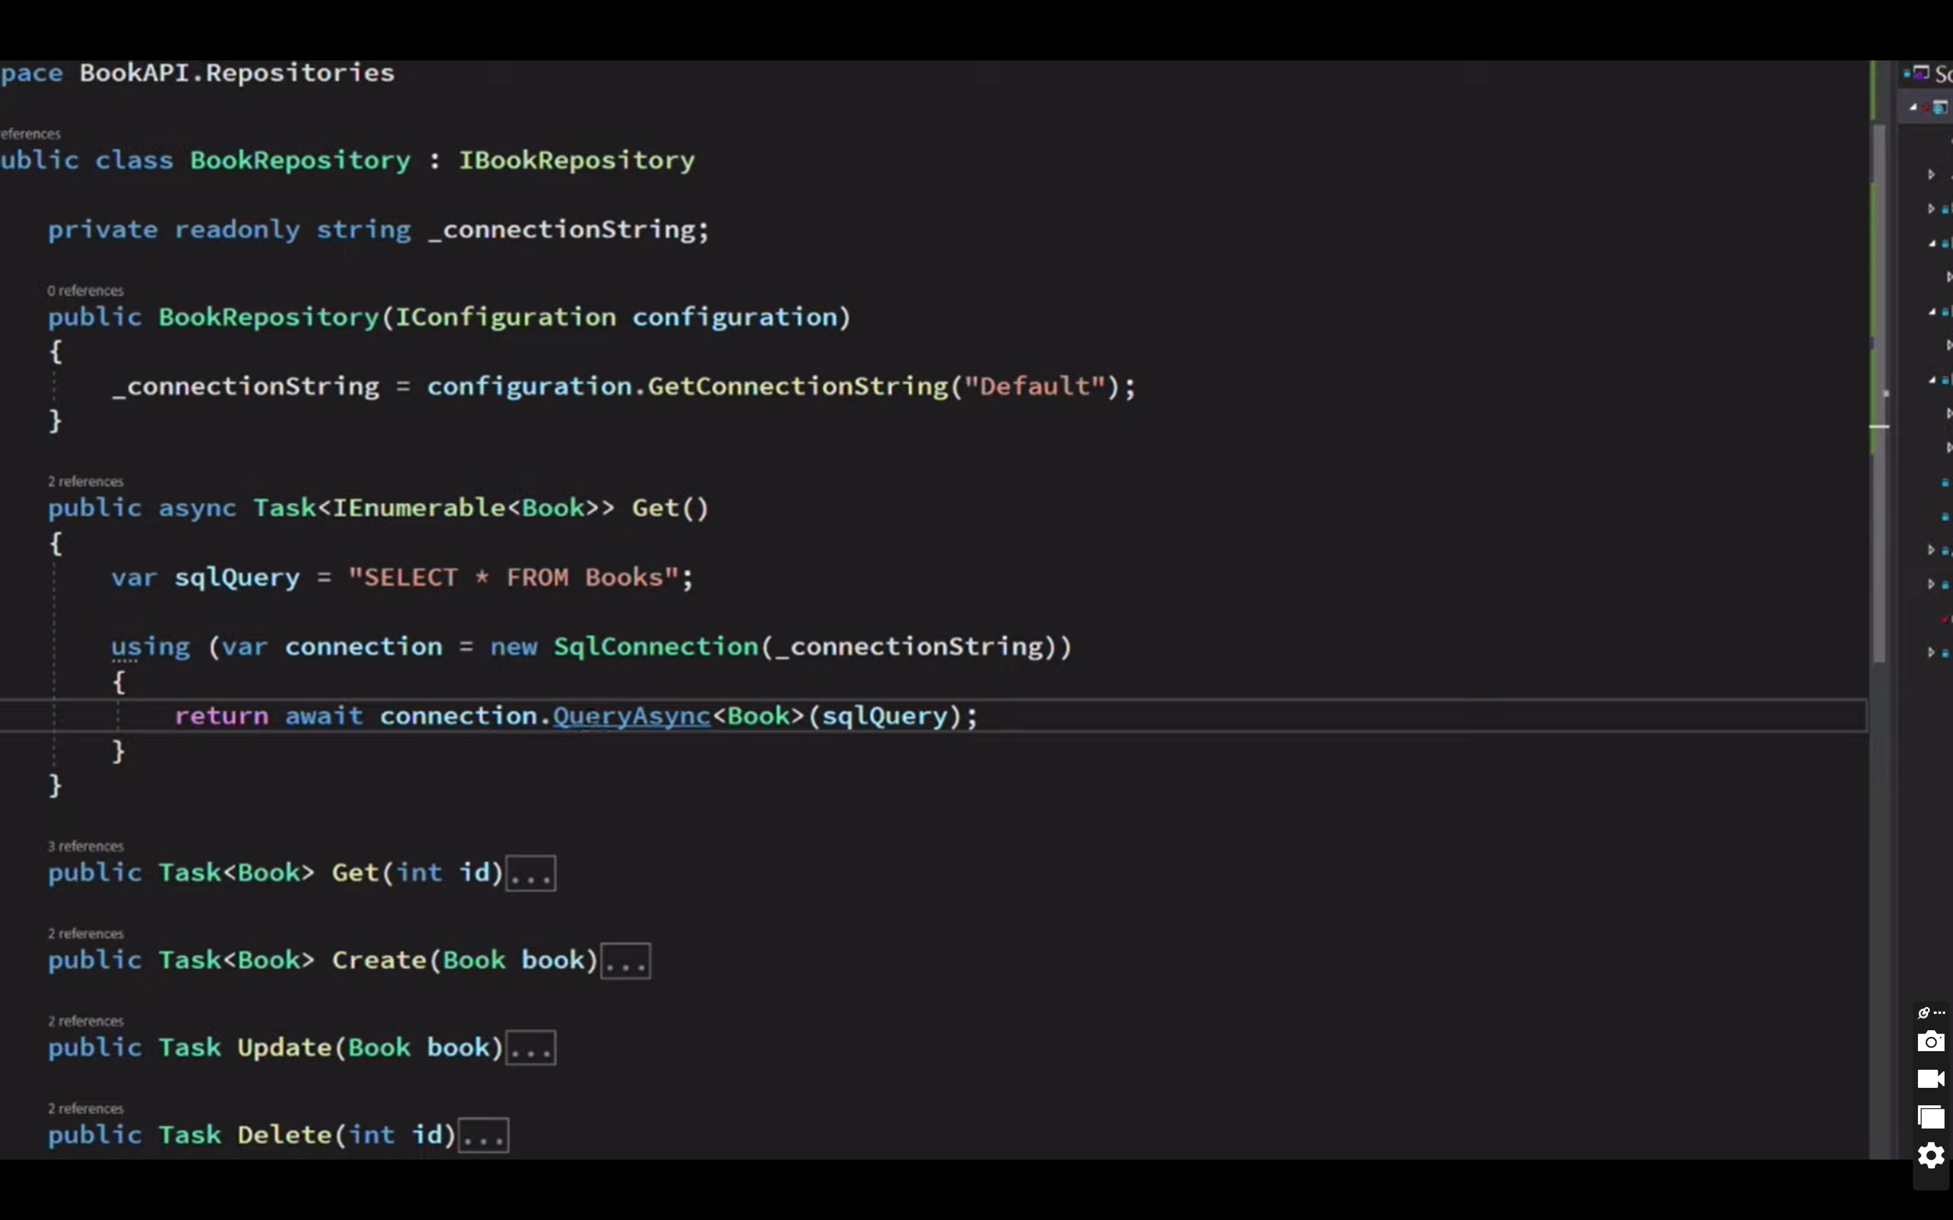

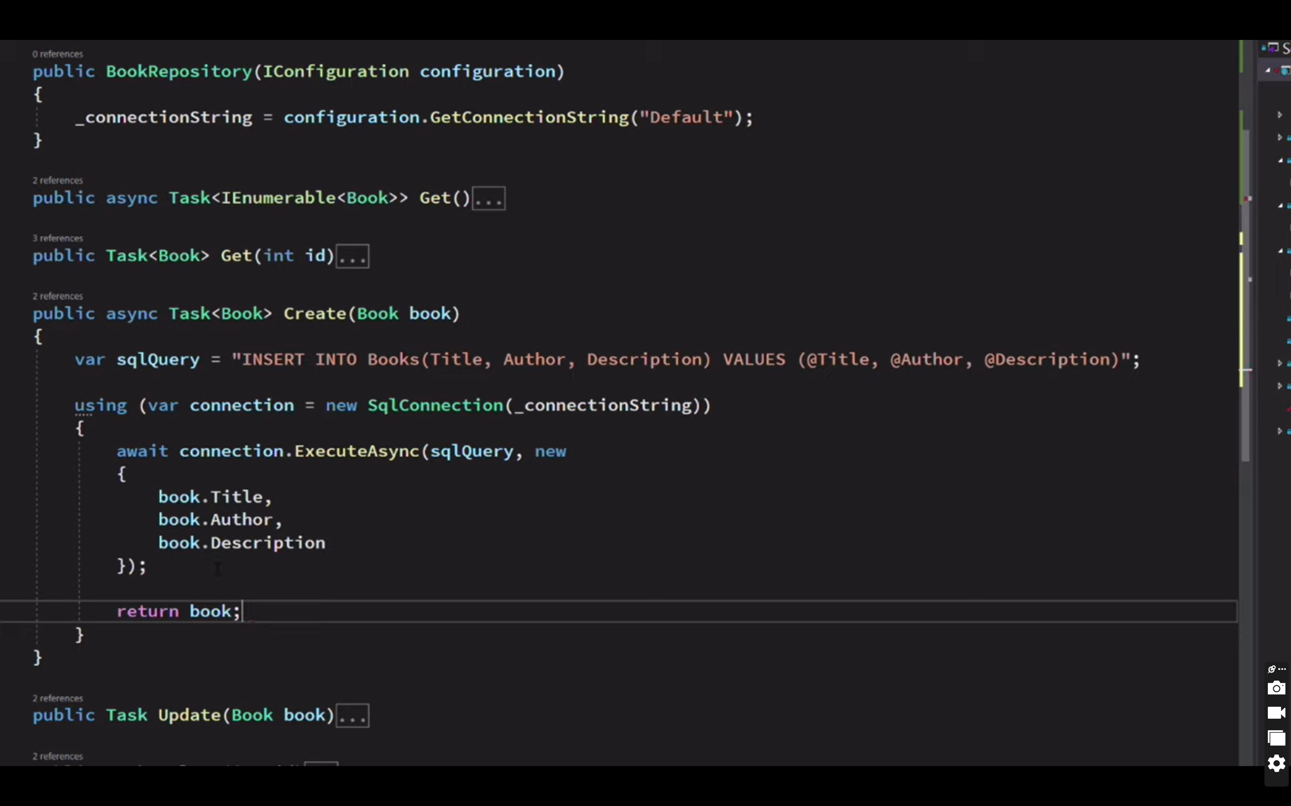

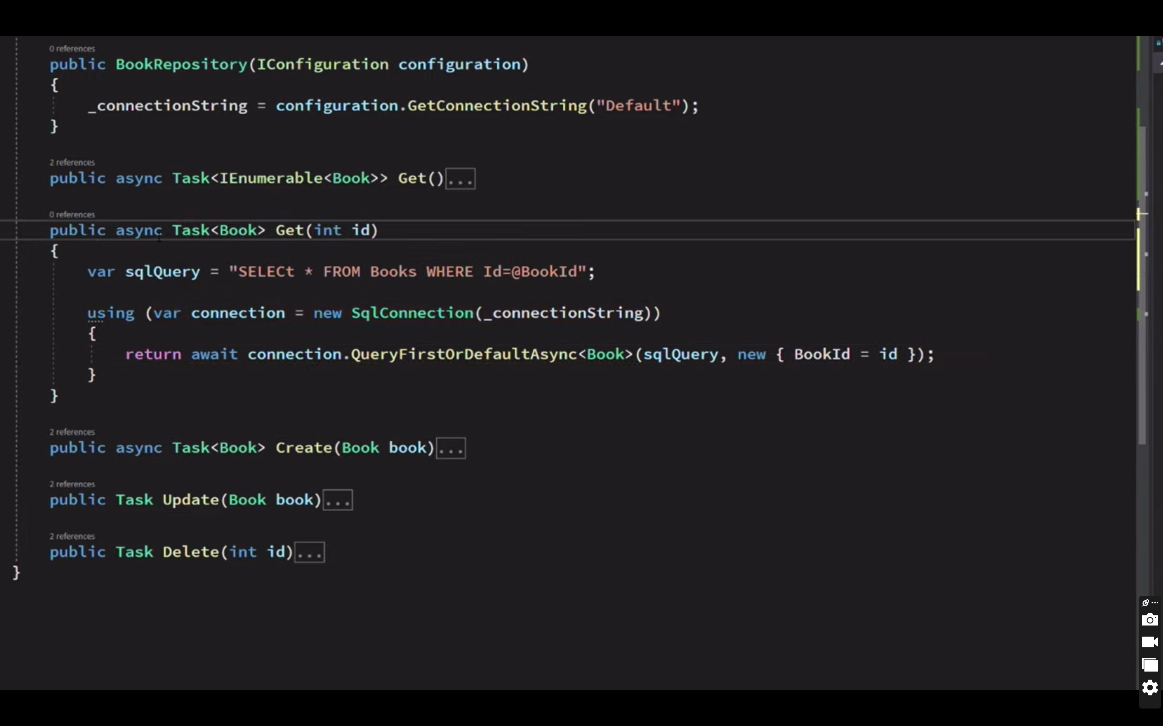

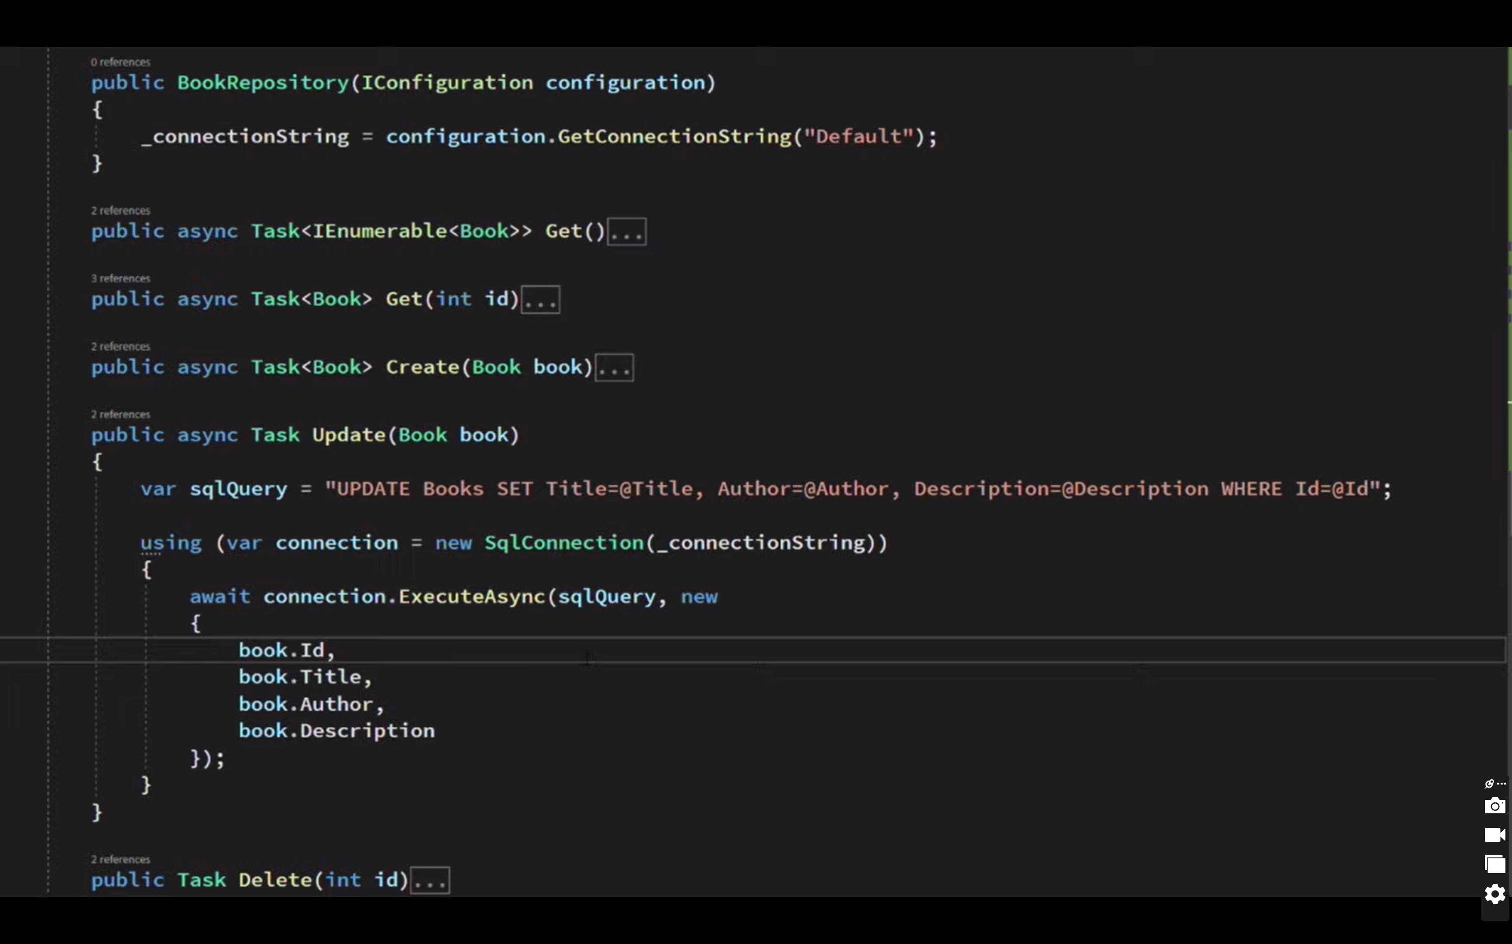

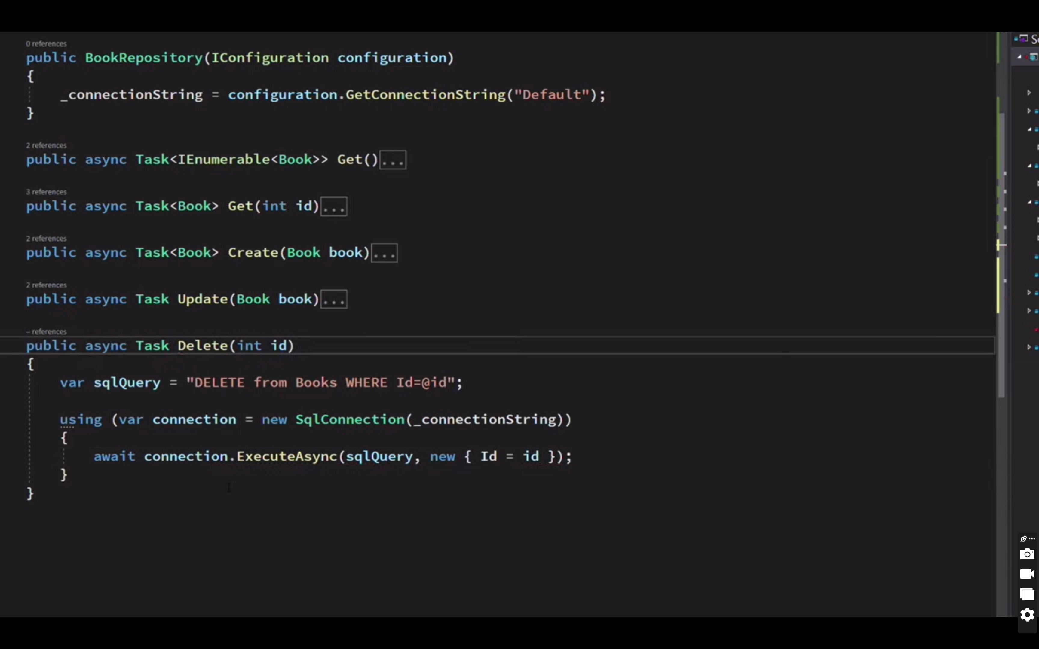

using Dapper;

using Microsoft.AspNetCore.DataProtection;

using Microsoft.Data.SqlClient;

using WebApi.IRepo;

using WebApi.Models;

using WebApi.Repository.Context;

using WebApi.Security;

namespace WebApi.Repository

{

public class StudentDapperRepo : IStudentRepo

{

StudentDbContext _context;

private string connectionString = string.Empty;

public StudentDapperRepo(StudentDbContext context, IConfiguration configuration)

{

_context = context;

connectionString = configuration.GetSection("ConnectionStrings1:DbConnection").Value; }

public void AddStudent(Student student)

{

var sqlQuery = "insert into students (name, address, marks, adharNumber ) values (@name, @address, @marks)";

using (var connection = new SqlConnection(connectionString))

connection.Execute(sqlQuery, new {

student.Name,

student.Address,

student.Marks});

}

}

public void DeleteStudent(int id)

{

var sqlQuery = "delete * from students where id=@id";

using (var connection = new SqlConnection(connectionString))

{

connection.Execute(sqlQuery, new { id = id });

}

}

public Student GetStudentById(int id)

{

var sqlQuery = "select * from students where id=@id";

using (var connection = new SqlConnection(connectionString))

{

return connection.QueryFirstOrDefault <Student>(sqlQuery, new { id = id });

}

}

public List<Student> GetStudents()

{

var sqlQuery = "select * from students";

using(var connection = new SqlConnection(connectionString))

{

return connection.Query<Student>(sqlQuery).ToList();

}

}

public Student UpdateStudent(int id, Student student)

{

var sqlQuery = "update students set address =@address where id=@id";

using (var connection = new SqlConnection(connectionString))

{

connection.Execute(sqlQuery,

new { student.Id,

student.Name,

student.Address,

student.Marks});

}

return student;

}

}

}